(Stress) test procedure for Hall efect current sensors
tools needed
1 30V Max @Min30A(ac or dc)
2 Current clamp
2 power meter
1 load that is big enough t carry a load current of Min 30A
1 temperature mesuering tool
1 fire extinguisher

Conection diagram
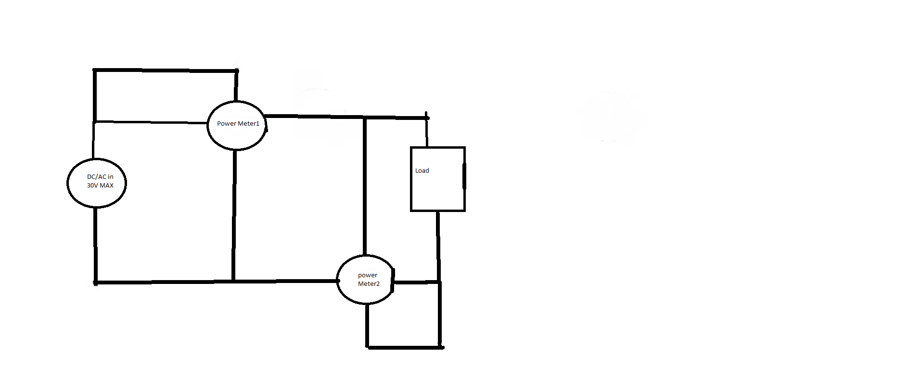
WorkFlow

1 set the power suply to a maximum voltage of 30V dc or ac

2 Conect the Power meter and load as in the picture show above

3 Set the load to 3 A
4 waith 30second
5 mesure and note power and ic package temperature
6 incerease the current whit 3 A
7 Repeat step 5 and 6 until A) it goes boem C) fault pin goes low or D 100A is reached

